Simple Linear Regression Mathematical Formulation

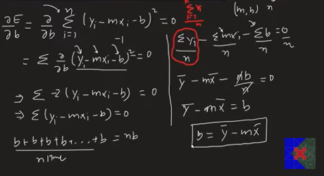

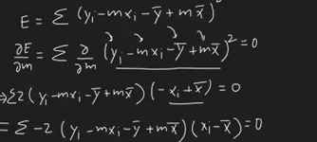

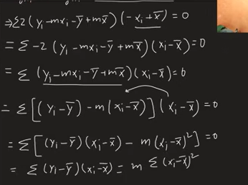

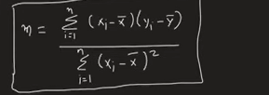

1. Introduction
Simple Linear Regression is a Supervised Machine Learning Algorithm used to predict a continuous numerical value using one independent variable.

Example
Input (X): CGPA
Output (Y): Package
Our goal is to predict the package based on CGPA.

2. Dataset
Suppose our dataset looks like this:
CGPA (X) | Package (Y)
6.5 | 5.5
7.0 | 6.2
8.1 | 8.5
9.0 | 10.2
When plotted on a graph, the points are not perfectly on a straight line.
So we need to find a line that passes as close as possible to all points.
This line is called the Best Fit Line.

3. Linear Regression Equation
The equation of a straight line is
y = mx + b
Where
- y = Predicted value
- x = Input feature
- m = Slope (inclination of the line)
- b = Intercept (where the line crosses the Y-axis)
Example
y = 2x + 5

4. Goal of Linear Regression
We need to find the best values of m and b so that the line passes as close as possible to all data points.

5. Prediction
Once we know m and b,
Prediction is
y_pred = mx + b
Example
m = 2
b = 1
x = 5

y_pred = 2 × 5 + 1

y_pred = 11

6. Error (Residual)
The prediction is usually not exactly equal to the actual value.
So,
Error = Actual Value - Predicted Value
Formula
Error = y - y_pred
or
Error = y - (mx + b)

7. Why Can't We Add Errors Directly?
Suppose
Error1 = +5
Error2 = -5

Total Error = 0
This is wrong because both predictions are incorrect.
Positive and negative errors cancel each other.
So we square every error.

8. Squared Error
For one point
Squared Error

= (y - y_pred)^2
or
(y - (mx + b))^2
Now every error becomes positive.

9. Cost Function (Loss Function)
The total error of the model is
J(m,b)

= Σ(y_i - y_pred_i)^2
Replacing y_pred
J(m,b)

= Σ(y_i - (mx_i + b))^2
This is called
- Sum of Squared Errors (SSE)
- Cost Function
- Loss Function

10. Objective of Linear Regression
Find m and b such that
J(m,b)
becomes minimum.
In simple words,
Find the line with the smallest total squared error.

11. Why is it Called Cost Function?
Because it tells how bad the model is.
Large Cost
↓
Bad Prediction
Small Cost
↓
Good Prediction
Minimum Cost
↓
Best Fit Line

12. Mean of X
x_mean

= (x1+x2+x3+...+xn)/n
or
x̄ = Σx / n

13. Mean of Y
y_mean

= (y1+y2+y3+...+yn)/n
or
ȳ = Σy / n

14. Formula for Slope (m)
m

= Σ((x_i-x_mean)*(y_i-y_mean))

/

Σ((x_i-x_mean)^2)
Meaning
Numerator
Σ((x_i-x_mean)*(y_i-y_mean))
Denominator
Σ((x_i-x_mean)^2)
Finally
m

= Numerator / Denominator

15. Formula for Intercept (b)
b

= y_mean - (m*x_mean)

16. Final Regression Equation
y

= mx+b

17. How Prediction Works
Suppose
m = 1.8

b = 0.9

x = 8
Prediction
y

= 1.8 × 8 + 0.9

=15.3

18. Mathematical Objective
We want
Minimize

J(m,b)

= Σ(y_i-(mx_i+b))²
This means
Find values of m and b that minimize total squared error.

19. Why Does Cost Depend on m and b?
Changing
m
changes the slope.
Changing
b
moves the line up or down.
Every different line gives a different error.
Hence
Cost

=

Function of m and b
or
J(m,b)

20. Error Surface
Imagine a 3D graph
X-axis
m
Y-axis
b
Z-axis
Cost
The graph looks like a bowl.
High Cost

▲

/ \

/ \

| |

\ /

\_____/

Minimum Cost
The bottom of the bowl gives the best values of
m

and

b

21. Calculus Behind Linear Regression
Since
J

depends on

m and b
we calculate
Partial Derivatives
∂J/∂m = 0
and
∂J/∂b = 0
After solving these equations,
we get
m

=

Σ((x_i-x_mean)*(y_i-y_mean))

/

Σ((x_i-x_mean)^2)
and
b

=

y_mean

-

m*x_mean
These are called the Ordinary Least Squares (OLS) formulas.

22. Two Ways to Find m and b

Method 1

Ordinary Least Squares (OLS)
Uses direct mathematical formulas.
Advantages
- Exact solution
- Fast for small datasets
- Used in Scikit-learn's LinearRegression

Method 2

Gradient Descent
Instead of formulas,
Start with random m and b.
Keep improving them until the cost becomes minimum.
Used for
- Multiple Linear Regression
- Deep Learning
- Large datasets
Implemented in Scikit-learn's SGDRegressor.

23. Why Gradient Descent?
Suppose there is only one feature.
CGPA → Package
OLS is easy.
Suppose there are
1000 Features
OLS becomes computationally expensive.
Gradient Descent is much faster.

24. Algorithm Flow
Dataset

↓

Calculate x_mean

↓

Calculate y_mean

↓

Calculate Numerator

Σ((x_i-x_mean)*(y_i-y_mean))

↓

Calculate Denominator

Σ((x_i-x_mean)^2)

↓

Calculate Slope

m

↓

Calculate Intercept

b

↓

Regression Equation

y = mx+b

↓

Predict

y_pred

↓

Find Error

↓

Find Cost

↓

Model Ready

25. Linear Regression from Scratch (Python Logic)

Step 1
Create class
class MyLinearRegression:

Step 2
Fit function
def fit(self, X_train, y_train):

Step 3
Calculate slope
numerator = 0
denominator = 0

for i in range(len(X_train)):
numerator += (X_train[i]-X_train.mean()) * (y_train[i]-y_train.mean())
denominator += (X_train[i]-X_train.mean())**2

m = numerator / denominator

Step 4
Calculate intercept
b = y_train.mean() - m*X_train.mean()

Step 5
Store values
self.m = m
self.b = b

Step 6
Prediction
def predict(self, X_test):

return self.m * X_test + self.b

26. Important Interview Questions

What is Linear Regression?
A supervised learning algorithm used to predict continuous values by fitting the best straight line.

What is the equation?
y = mx+b

What is m?
Slope of the line.

What is b?
Intercept of the line.

What is Error?
Error = Actual − Predicted

What is Cost Function?
J(m,b)

=

Σ(y_i-y_pred_i)^2

Why square the error?
- Removes negative signs.
- Penalizes large errors more heavily.
- Makes the function differentiable.

Which algorithm does LinearRegression use?
Ordinary Least Squares (OLS).

Which algorithm does SGDRegressor use?
Gradient Descent.

One-Page Formula Sheet (Revision)
Linear Equation

y = mx + b

Prediction

y_pred = mx + b

Error

Error = y - y_pred

Squared Error

(y - y_pred)^2

Cost Function

J(m,b) = Σ(y_i - (mx_i+b))²

Mean of X

x_mean = Σx / n

Mean of Y

y_mean = Σy / n

Slope

m = Σ((x_i-x_mean)*(y_i-y_mean))
/
Σ((x_i-x_mean)^2)

Intercept

b = y_mean - m*x_mean

Final Model

y = mx+b
These notes are structured for college exams, interviews, and ML revision, and the formulas are written in a plain-text format so they stay readable when copied into Word, Notion, or any text editor.

